

ACME-SF

G1.007

**Planning and progress report**

26/04/2024



# Cover

Repository:<https://github.com/DP2-C1-07/Acme-SF-D03>

### Student #1 Student #2

ID: 31878881F ID Number:49034820Q

UVUS: pabcabmar3 UVUS: mararnmon

Name: Caballero María, Pablo Name: Arnáiz Montero, Marco Antonio Roles: manager, developer Roles: developer, operator

### Student #3 Student #4

ID Number: 77865211E ID Number: 53932912M

UVUS: alfalolan UVUS: albsanmim

Name: Alonso Lanzarán, Alfonso Luis Name: Sánchez Mimbrero, Alberto Roles: developer, tester Roles: developer

### Student #5

ID Number: 48123111G

UVUS: juagarcar4

Name: Garcia Carballo, Juan

Roles: developer

Table of contents

Cover 2

Executive summary 3

Revision table 3

Introduction 3

Contents 3

Planning chapter: 3

Progress chapter 6

Conclusions 7

Bibliography 7

# Executive summary

# Revision table

|  |  |  |
| --- | --- | --- |
| Number | Date(dd/mm/yyyy) | Description |
| 1.0 | 26/04/2024 | Document done in its entirety |

# Introduction

The purpose of this document is to provide a detailed planning and progress report of the third delivery of the project “Acme-SF-D03”, for the subject “Design and Testing 2”. This is divided into two chapters: planning (specifying the requirements set for this delivery, assignees, roles, planned time, actual time, budget estimation...) and progress (assignees performances, conflicts arisen, actual cost in contrast to the estimations...).

This document has an executive summary, a revision table where there are versioned records, this introduction, the main content (divided into a planning, and a progress chapter), and the conclusions of the report.

# Contents

## Planning chapter:

List of taks for the second deliverable:

Next, there are screenshots that shows different moments of the delivery development.

Beginning:

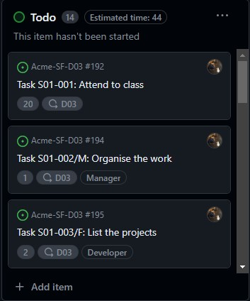

Middle:

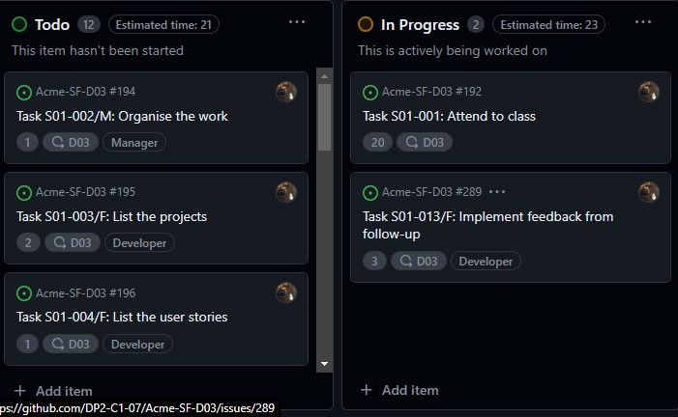

End:

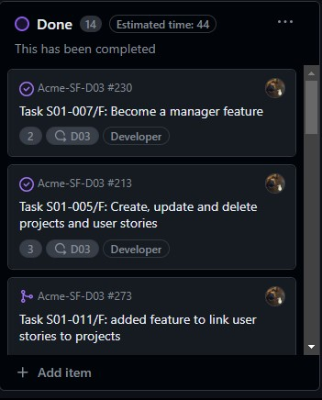

Next, it is shows the calculation of the estimated budget:

|  |  |  |
| --- | --- | --- |
| Title | Estimated time | Role |
| Task S01-007/F: Become a manager  feature | 2 | Developer |
| Task S01-005/F: Create, update and delete projects and user stories | 3 | Developer |
| Task S01-010/F: Add feature to link user stories to projects | 1 | Developer |
| Task S01-008/F: List the projects in the systems that are published | 2 | Developer |
| Task S01-006/F: Show manager dashboard | 2 | Developer |
| Task S01-009/F: Add draftMode attribute | 2 | Developer |
| Task G01-001/F: List the claims | 5 | Developer |
| Task S01-001: Attend to class | 20 | Student |
| Task S01-013/F: Implement feedback from follow-up | 3 | Developer |
| Task S01-002/M:  Organise the work | 1 | Manager |
| Task S01-003/F: List the projects | 2 | Developer |
| Task S01-004/F: List the user stories | 1 | Developer |

Total cost for tasks = 890€

Equipment cost = 700 €

Considering a lineal amortization over 3 years, the yearly amortization cost is 530€

## Progress chapter

Progress records:

Member: Pablo Caballero María

Performance indicators: Total tasks done/total tasks to do ratio is 1, which is considered “good” according to the chartering report. Along these lines, I will be granted the privilege to choose the role for the next delivery.

The conflicts that arose during this delivery were related to the file menu.jsp, wich every member of the group had to edit at some point. The resolution of the conflicts was simple, just merging the incoming changes of each member.

Next, there is a table showing the actual budget consumed by the project:

|  |  |
| --- | --- |
| Title | Invested time |
| Task S01007/F:  Become a manager feature | 2 |
| Task S01005/F: Create, update and delete projects and user stories | 6 |
| Task S01-  010/F: Add feature to link user stories to projects | 4 |
| Task S01-  008/F: List the projects in the systems that are published | 2 |
| Task S01006/F: Show manager dashboard | 2 |
| Task S01009/F: Add draftMode attribute | 4 |
| Task G01-  001/F: List the claims | 2 |
| Task S01-001: Attend to class | 20 |
| Task S01013/F:  Implement feedback from follow-up | 6 |
| Task S01002/M: Organise the work | 1 |
| Task S01-  003/F: List the projects | 3 |
| Task S01-  004/F: List the user stories | 3 |

Total cost for tasks = 1110 €

Equipment cost = 1810 €

Considering a lineal amortization over 3 years, the yearly amortization cost is 603.33 €

Comparing, we can calculate that yearly cost would be a 13.83 % than the cost that was estimated.

# Conclusions

The planning of tasks was done using GitHub projects. This deliverable was particularly challenging, as many features had to be done, which required several iterations to get them working.Also, in this delivery, we considered the cost of tasks in hours, rounding to the nearest integer greater than 0.

# Bibliography

Intentionally blank.